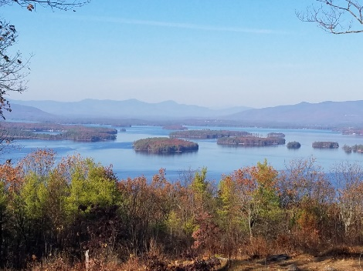
KIMBALL WILDLIFE FOREST COMMITTEE
MEETING Minutes: August 4, 2022; 4:00 PM
Gilford Town Hall Conference Room or Zoom
- Attendance: Rebecca Watson, Gail Tebbetts, Alexandra Breed, Dan Tinkham, Karl Gould, Rebecca DiGirolomo, Sandra McGonagle, Pat Bennett
(Sandy noted that Tim Nolan had planned to join us by video but our system is not working.)
Visitor: Mel Ingles
Committee members introduced themselves.

- Approval of minutes – May 26, 2022
Moved by Alexandra Breed; seconded by Rebecca Watson; minutes approved.

- Old Business:

- Trail Updates-Karl

Karl reported that as of about 3 weeks ago the trail was in good shape. There was discussion about continued concern at the switchback. It was recommended that some reblazing needs to be done. Karl will get paint and work on that. He would also like to improve the area under the power line at the top.

Karl commented that he had done some trimming at the overlook on the Lakeview Trail. He had hoped it would stimulate blueberry growth but that has not happened. Rebecca D. discussed some possible reasons.

Sandy asked Karl to be thinking of potential fall projects for the Boy Scouts.

There was some discussion about the problem of people leaving behind the dog poop bags! Perhaps we need to add signage for that!

Mel Ingles, visitor, hikes the trail frequently (sometimes with a saw in hand!) and offered to help Karl if he needs assistance.

- Status of maps/trail guide

It appears that we are out of trail brochures. It was agreed to order 500 trail brochures.

Revision work on the brochure will be put on hold until trail reconstruction is completed and there is further discussion regarding additions to signage, especially as it might apply to the incorporation of information related to indigenous people and cultures.
As part of a discussion on signage Alexandra recommended we look at what has been done at the Manchester Cedar Swamp Preserve and the recently opened All Person’s Trail. She specifically mentioned the signs, some of which are fairly large and are illustrated. Sandy suggested a visit to the site. Rebecca D. is going to see if she can get some examples of their signage for us to see. The question arose as to whether we would do some “patchwork” to our existing signs or consider a more complete revision. It was suggested that there should be a guiding theme for the signage – for example, wildlife education. Additional comments on signage included painting a frame around signs so they are more visible. Our visitor, Mel, suggested that we might consider a sign at the beginning of both the Lakeview Trail and the Quarry Trail to remind hikers to “look for” the signs. Sandy commented that we might want to assemble a subcommittee this winter to work on an overall plan for trail signage. (Include on the agenda for September 15th.)
4. New Business
- Discussion on the summary and recommendations from Rebecca D. on the hike with Denise and Paul Pouliot.

Rebecca D. summarized some of the information learned on the June 23rd hike with Denise and Paul Pouliot. The Pouliots are active in the indigenousNH movement which is working to identify sites of interest around the state. (Refer to Rebecca’s email of June 23 to Sandy and others which identifies some of the specific examples of the sites of interest on the trail as well as how we might incorporate them.)

- Updates on Town 4 Trail Services project (Erin Amadon) timelines…signage in preparation for construction.

Dan informed us that Erin plans to be on site August 25th to map out the work. This may include a little bushwhacking. She will then provide us with a schedule. Sandy asked Dan if he would discuss with Erin measures we would need to take to prepare for the work – signage, closing the trail, etc.

- Discussion on a question from Erin Amidon asking if there are any limitations for working on the Kimball Forest Trails with regard to potential impacts on bad habitat.

Dan reported that Erin had questioned whether there were any habitat issues of which she needed to be concerned. The committee will check with Tim but Scott Dunn indicated he didn’t think so.

- Other

- Tim Nolan – painting of boundaries

Tim has finished painting the boundaries with red boundary paint and has prepared a sketch map with problem areas highlighted in yellow. (Sandy will forward copies of Tim’s map.) He has submitted a bill of $963.50 for forestry labor and paint. Sandy proposed a recommendation to the Board of Selectmen that Tim Nolan be paid $963.50 for his services. The recommendation was moved by Alexandra and seconded by Dan. All were in favor.

- Rebecca D. has a lead on someone who might be able to assist us with a prescribed burn. She asked if she could discuss our situation with him and Sandy gave her the okay.

- Sandy thanked Mel Ingles for his interest in KWF and invited him to join our committee. She explained the process to him.

Next meeting: Thursday, September 15, 2022
Respectfully submitted,
Pat Bennett

