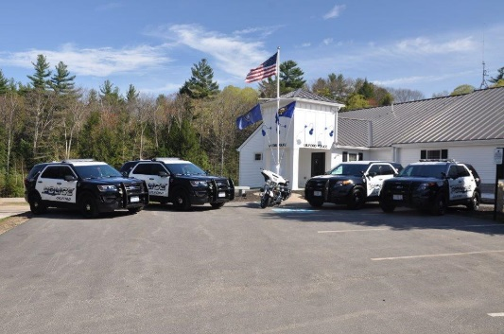

Gilford Police Department

Citizen’s Police Academy
________________________________________________________________________

We welcome your interest in our Citizen’s Police Academy. The main goal of the academy is to educate citizens with the operation of the police department while obtaining valuable feedback from those citizens. The 12-week program is designed to expose citizens to the day-to-day workings of the police department and to help them understand the role of Law Enforcement in our society. The academy will start on Tuesday, February 19, 2019 at 6pm, and is scheduled to meet each subsequent Tuesday from 6pm-9pm. The classes will be taught by Gilford Police Officers and will consist of three-hour blocks, held once a week for twelve weeks. Topics will cover a broad range of modern policing such as: Criminal and Motor Vehicle codes, Patrol Procedures and tactics, DWI recognition, Officer Safety, Defensive Tactics, weapons familiarization and much more. Participants will also be given the opportunity to ride along with members of the Patrol Division.

Anyone that lives or works in the Town of Gilford who is at least 21 years of age is eligible to apply for The Academy. All applicants will be subject to a background check before being accepted into the program. The Academy will be limited to 15 Citizens. We also ask that all citizens enrolled in the academy be able to attend at least 75% of the classes.

The Gilford Citizen Academy is for informational purposes only and at no time should participants act as a law enforcement officer.

Thank you for your interest in the Gilford Police Department Citizen’s Academy. We look forward to seeing you!

To apply for the academy, please visit the PD’s website at, www.gilfordpd.org and click on “Citizen’s Police Academy” link. Questions can be directed to Patrolman First Class Douglas Wall d.wall@gilfordpd.org or Sergeant Adam VanSteensburg a.vansteensburg@gilfordpd.org at 527-4737. If contacting PFC Wall or Sgt VanSteensburg by phone please allow several days for a response due to work rotation schedules.

Applications must be submitted to the Gilford Police Department by Thursday, January 31, 2019.

